Walk 20 Marcle Ridge
Last walked in October 2017

Description. A 6km (3.7mile) moderate walk up and down the Ridge. Fine views across south and east Herefordshire. Along a ridge, thru fields and country lanes.
Start. Explorer Map 189 Grid 630346.
Directions from the Fire Station. (Turn milometer to zero). 200 yards passed the Fire Station TR signed 'Fownhope B4224'. After 3.9 miles, (in Mordiford) TL signed Woolhope. After 6.8 miles, (in Woolhope) TL at a T-junction and continue on main road signed for Ledbury. Keep R thru the next village and at a road junction, after 7.7 miles, TR signed Much Marcle. Go up the hill and along the ridge and at 8.8 miles TR at the next junction on the R and park on the L. (2 blue sign posts at this site: Unsuitable for HGV’s and Unsuitable for LGV’s).

1. Marcle Ridge Car Park. From the car park you go back up to the Much Marcle road and go up the public footpath steps on your R, over a stile and into F1, (you will now be following the R hand field edge and along the inside edge of the woods on your R for the whole length of the ridge, heading towards the TV and Radio Mast). Go thru a gate gap into F2. Just over half way up this field you will TR and go thru a small way marked metal gate and into the woods. TL and walk along the inside edge of the woods (fields are on your L). A little further along you pass a Trig Point. Walk in the same direction as you leave the inside edge of the wood and continue along an enclosed grassy track (fields L, shrub R). Go past the major TV and Radio transmitter ,which is in the field on your L, and continue along to the end of the enclosed grassy path to reach a metal gate. Don’t go thru the gate but TL and go thru a small broken metal gate into F3, then TR and continue along the R hand edge of the field and down to some wooden steps to go thru a wooden kissing gate and onto an enclosed track. TL and walk up the wide aggregated track. Keep ahead at the crossroads, now surfaced, and go past the Primitive 1858 Methodist Chapel on your R. Continue on past ‘Upper Nuttal’ on your R, then underneath power lines to reach ‘Nuttal Cottage’ that is also on your R.

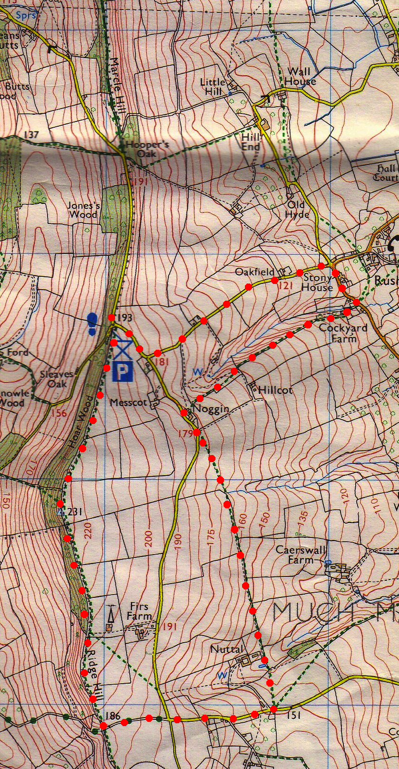
2. Nuttal Cottage. Directly opposite, TL across a double stile and into F4. Go across the field, following the power lines, and go thru three gates to the R of Nuttal Farm and into a small orchard. Continue in the same direction and go thru two more gates and into F5. Keep to the R edge (the TV/Radio mast is up the hill off to your L) and go thru a gate into F6. Continue in the same direction going thu more fields and gates and then you cross over a stile. At the end of this field you cross over a low fence where there once was a stile that’s in a dip and into F7. Bear L and go across the field, thru a swathe of crops, heading for a lone oak tree. Go past the oak tree and thru a gate in the field corner and onto a road. Walk in the same direction along the road, passing the farm house called Noggin (R). Just beyond a corrugated iron roofed barn at the far end of farm, TR across a stile onto a track. After 40m you TL across a stile and into a field, then you turn immediately R over another stile and into another field (F8). Keep in the same direction as you walk along the top R edge of the bank in the sloping field for about a km, following the power lines all the way. Go thru a makeshift gate into F9. The bank descends and when you get near to the path/brook on the L side, follow the power lines and TR to cross over a stile that’s above and to the R, into F10. TL, follow power lines down to the L hand corner of the field where you TL and go down a set of wooden steps with hand rail. TL along farm track to the road just beyond Pear Tree Cottage.

3. Rushall. TL and walk up to the crossroads (a walled red post box is in front). TL and walk uphill towards Woolhope. When you get to the T-junction you TR, heading towards Woolhope. The car park is further on the L, near the bend in the road.
3
1
2

